***Assignment – 9***

Querying Multiple Tables at Once.

1. Write a query that lists each order number followed by the name of the customer who made the order.

Ans 1)

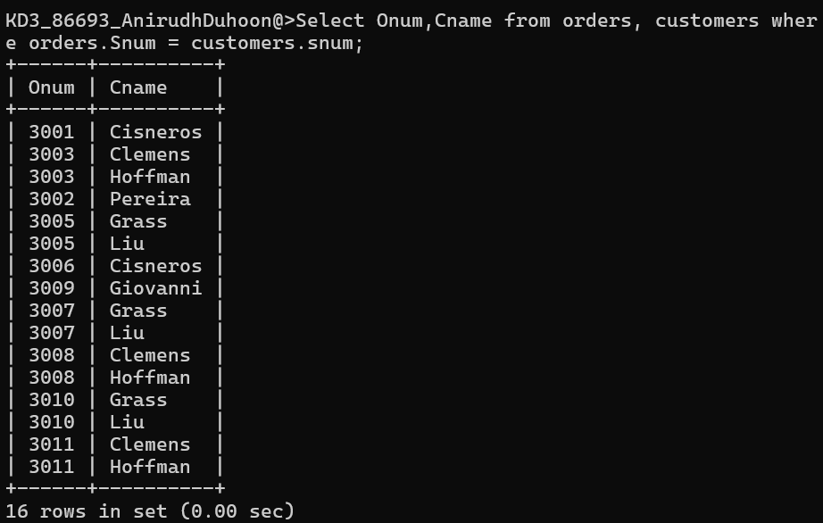

1. Write a query that gives the names of both the salespeople and the customer for each order along with the order number.

Ans 2)

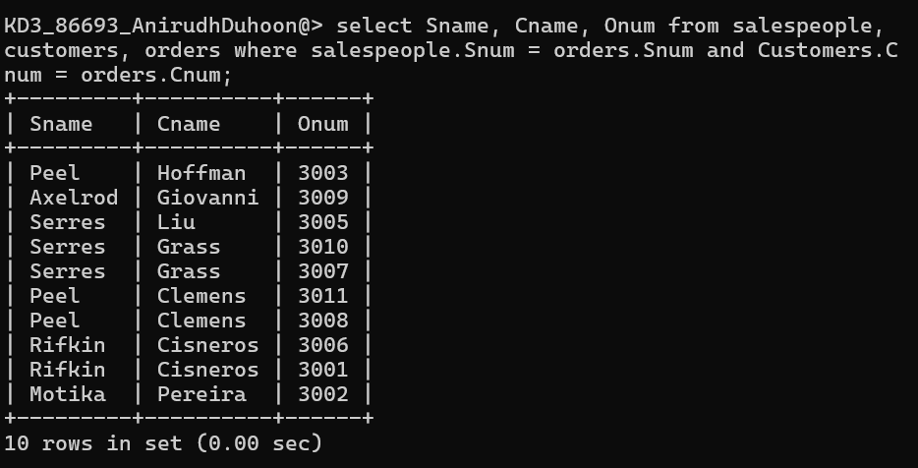

1. Write a query that produces all customers serviced by salespeople with a commission above 12%. Output the customer’s name, the salesperson’s name, and the salesperson’s rate of commission.

Ans 3)

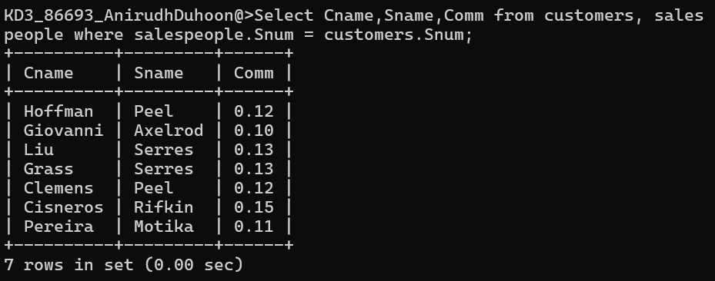

1. Write a query that calculates the amount of the salesperson’s commission on each order by a customer with a rating above 100.

Ans 4)

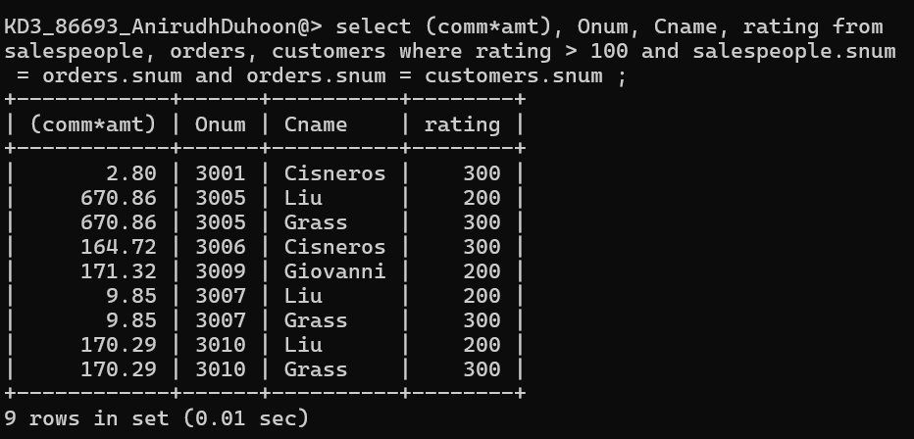

*Sameer Dehadrai* Page: 1